Project Design Phase-II Technology Stack (Architecture & Stack)

|  |  |
| --- | --- |
| Date | 15 October 2022 |
| Team ID | PNT2022TMID51465 |
| Project Name | Project - AI-powered Nutrition Analyzer for Fitness Enthusiasts |
| Maximum Marks | 4 Marks |

# Technical Architecture:

The Deliverable shall include the architectural diagram as below and the information as per the table1 & table 2

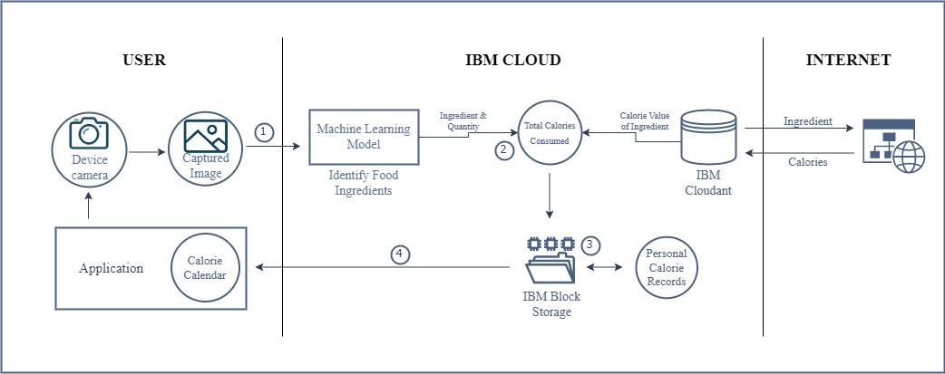

# Table-1 : Components & Technologies:

|  |  |  |  |  |  |  |  |  |  |  |  |  |
| --- | --- | --- | --- | --- | --- | --- | --- | --- | --- | --- | --- | --- |
| **S.No** | **Component** | **Description** | | | | | | | **Technology** | | | |
| 1. | User Interface | An application where users create a profile, capture images of the ingredients they use in their food, and have access to a bespoke nutrition calendar | | | | | | | HTML, CSS, JavaScript | | | |
| 2. | Image Capture | Users must capture the image(s) of the ingredients they consume | | | | | | | IBM Maximo Image Inspection | | | |
| 3. | Ingredient Detection Model | The ingredients captured image | used | must | be | identified | from | the | Machine Learning & Image Processing using Python | | | |
| 4. | Calorie Consumption Monitoring | The application keeps track of the calories consumed by the user in a day and notifies when there is over-consumption | | | | | | | IBM Push Notifications | | | |
| 5. | Database of Ingredients | The data of ingredients and their corresponding calories are stored | | | | | | | MySQL | | | |
| 6. | Cloud Database for Back-up | Data used by the application is stored here for back-up and monthly calendars are stored as consolidated reports | | | | | | | IBM Cloudant | | | |
| 7. | File Storage | Per-day calorie consumption along with items consumed is kept track using a file system. This is used to generate a personal calorie calendar as well | | | | | | | IBM Block Storage | | | |
| 8. | Calorie Value Consolidation | A web-scraping API is employed to find the calorie values of ingredients which are stored in the database | | | | | | | Beautiful Soup | | | |
| 9. | Machine Learning Model | Captured images are processed using machine learning models to identify ingredients | | | | | | | Object Recognition Ingredients | Model | to | Label |
| 10. | Infrastructure (Server / Cloud) | The application is deployment on cloud for use Cloud Server Configuration : | | | | | | | Cloud Foundry | | | |

**Table-2: Application Characteristics:**

|  |  |  |  |
| --- | --- | --- | --- |
| **S.No** | **Characteristics** | **Description** | **Technology** |
| 1. | Open-Source Frameworks | Google Colab, VS Code, Online Websites | Python, HTML, CSS, JavaScript |
| 2. | Security Implementations | E-mail based authentication for data access and encryption of text before storing in files | SMTP, Encryption Algorithms |
| 3. | Scalable Architecture | Application is revised based on user experience and feedback including updates, bug fixes, and inclusion of new features | Customer feedback, reviews, and ratings |
| 4. | Availability | Users should be able to access the application that is hosted on the cloud at all times and should not face any issues such as application crash | IBM Cloud |
| 5. | Performance | Application should handle large number of requests and should not compromise on quality of results and time taken | Testing - Black, White, and Beta Revise application in spiral model |